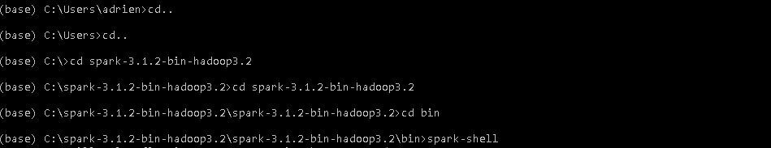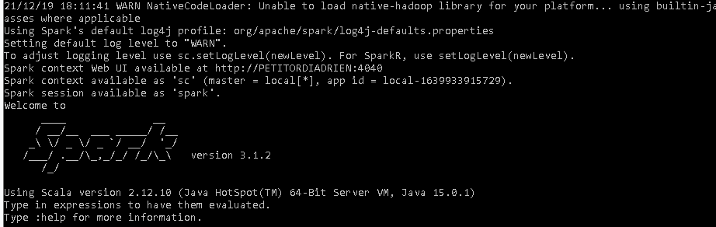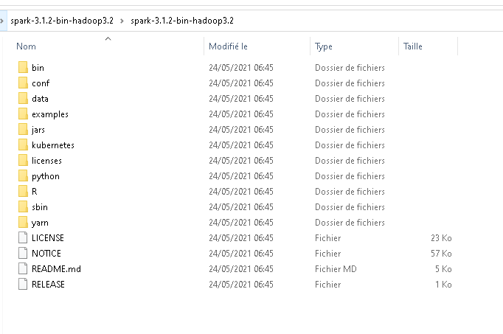

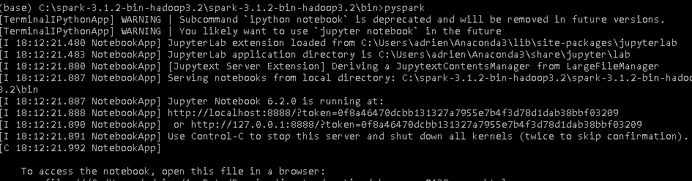

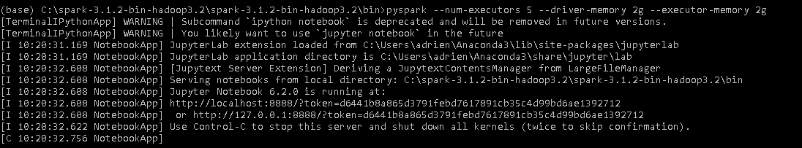

pyspark –num-executors 5 –driver-memory 2g –executor-memory 2g

#### **Community area names**

Let's link names of these community areas. These float numbers are having a hard time making any sense...

Sourced from Chicago Tribune at<http://www.chicagotribune.com/chi-community-areas-htmlstory.html>

Requêtes map reduce depuis python

<https://api.mongodb.com/python/2.0/examples/map_reduce.html>